Geometry and Measures – Transformations

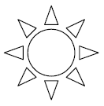
(1) With a ruler, draw on the lines of symmetry on the following shapes and write how many lines of symmetry the shape has.
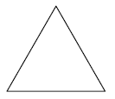
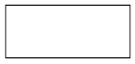
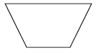
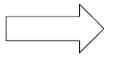

(2) Write down 3 letters of the alphabet that are symmetrical.

(3) Reflect the following shapes in the lines of reflection.
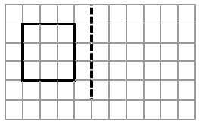
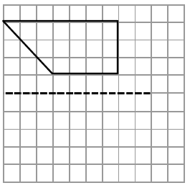

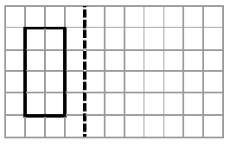

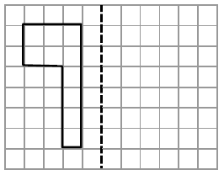

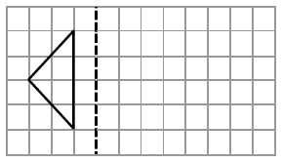

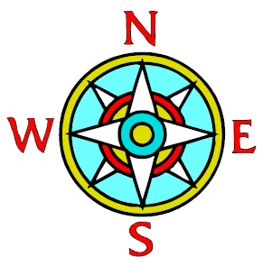
(4) Look at the diagram of a compass.

Start at North.
Which direction will you end up facing if you turn:

a) ¼ turn clockwise

b) ¼ turn anticlockwise

c) ½ turn clockwise

d) ¾ turn anticlockwise

e) 90º clockwise

f) 270º clockwise

g) 360º anticlockwise

h) 180º clockwise

(5) Using the same diagram of the compass, describe the rotation, in degrees, to get from:
(don’t forget to write the direction – clockwise or anticlockwise)

a) N to S

b) W to S

c) N to W

d) W to E

(6) Follow the instructions and draw the shapes in the end position.
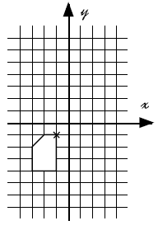

a) Move the shape 5 squares to the right and 6 squares up.

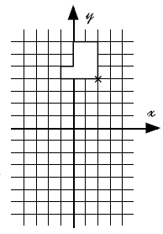
b) Move the shape 3 squares to the left and 8 squares down.

Extension
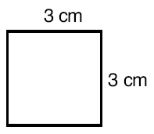

Draw a square twice the size of the square shown. Use a ruler and a pencil and label the lengths of the sides. (The square is not to scale)

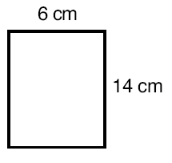

What would the lengths of the sides of a rectangle which is 3 times as big as the one shown? Draw a sketch (not to scale) and label the lengths of the sides.

